AWS SaaS Steps
Step 1: Go to AWS Marketplace Management Portal.
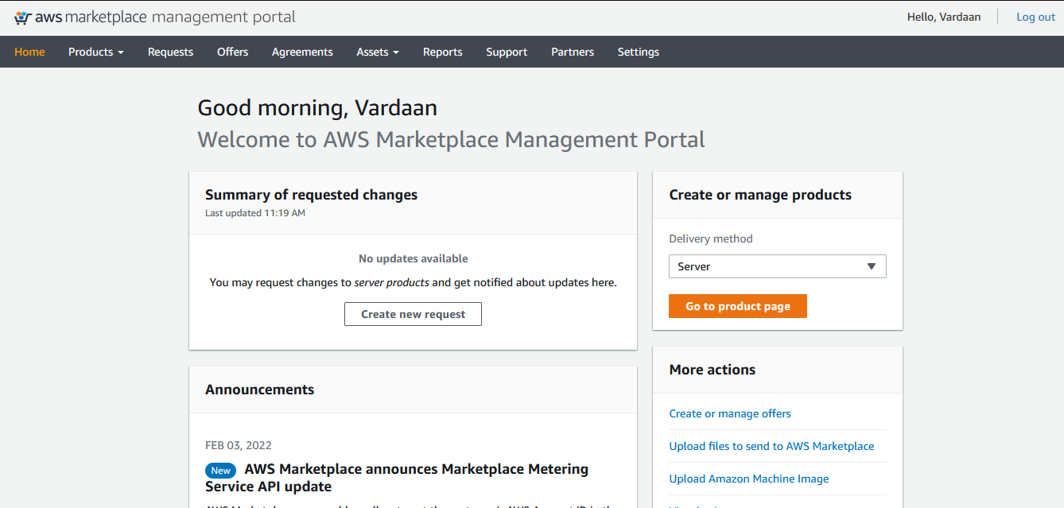

Step 2: Go to Products and then click on SaaS;
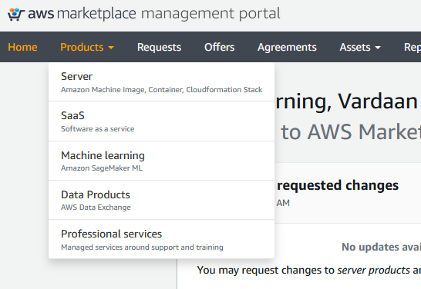

Step 3: Now you will get SaaS Homepage, click on create SaaS product on the top right;
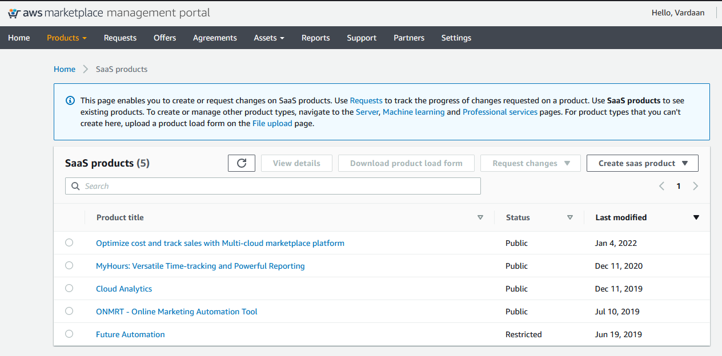

Step 4: Here you will get two options, New SaaS Contract and New SaaS Subscription;
If you want a contract-based SaaS then click on New SaaS Contract otherwise click on New SaaS Subscription;
In our case, we have created a New SaaS Subscription.
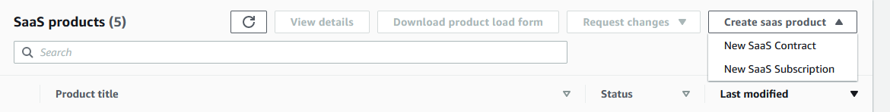

Step 5: Tick the Below Details;
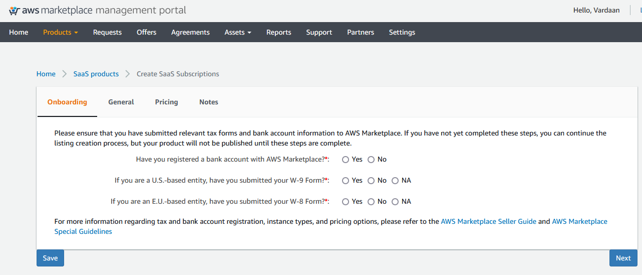
Then click on Next;
These details should be provided by the Organisation.

Step 6: Fill the Following details as provided by the Organisation.
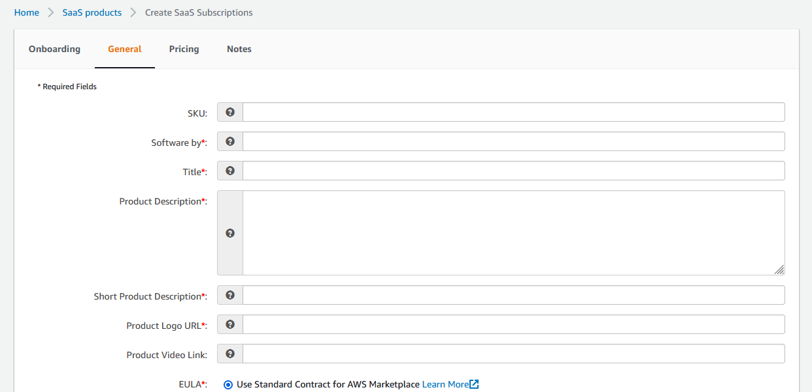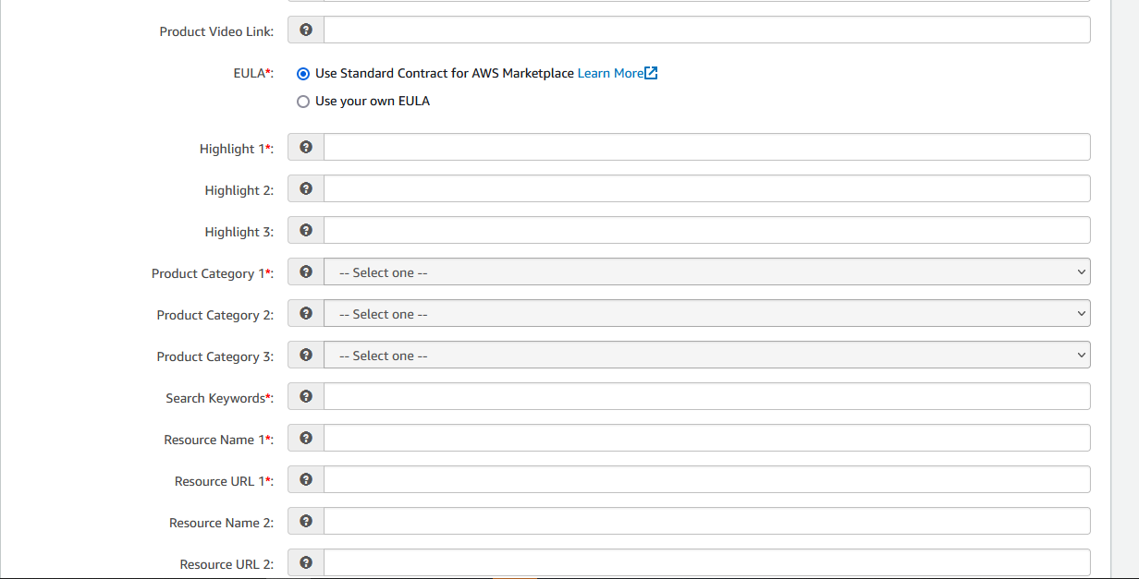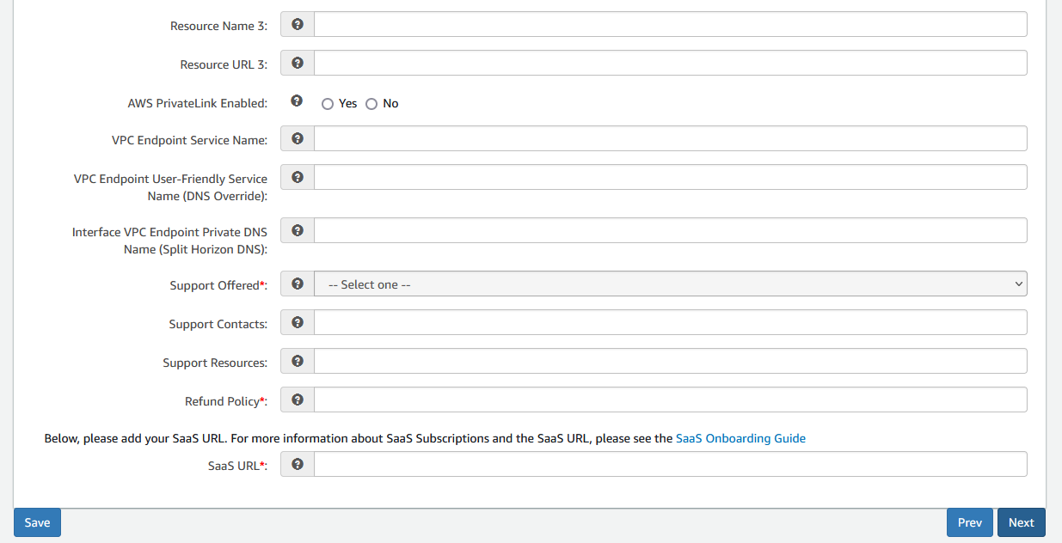
Note:
- EULA stands for End-user License Agreement.
- You have to fill the link for logo and EULA, best practice is to upload these into S3 then fill in the field given.
- Highlight - Specify the type of product like Its CRM or Automation Tool.
- Select the product category.
- Resource Name – About/Overview
Resource URL – Provide the link of About the Product.
- SaaS URL – Fill the SaaS URL here, it will be the homepage of the SaaS where the customers will be Directed to create account or fill other details.
- Refund Policy – It will be specified by the organisation whether they provide refund/no-refund policy.

Then Click on Next;

Step 7: Now we have come to Pricing;
- Select the Targeted Customers, this implies where you want to sell your product on the Marketplace.
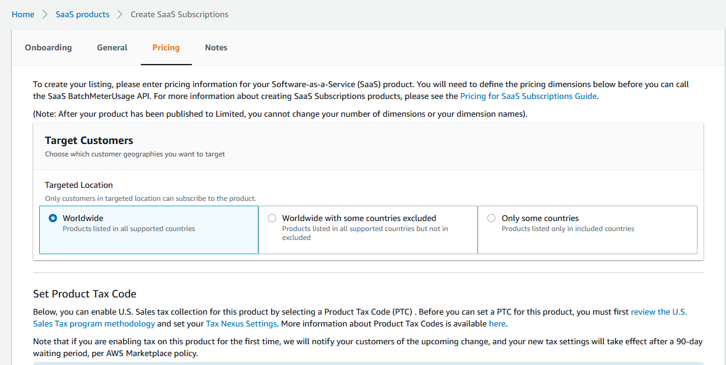
Select the appropriate option according to your Requirements.

- Tax policy, leave it as default or as specified by the organisation.
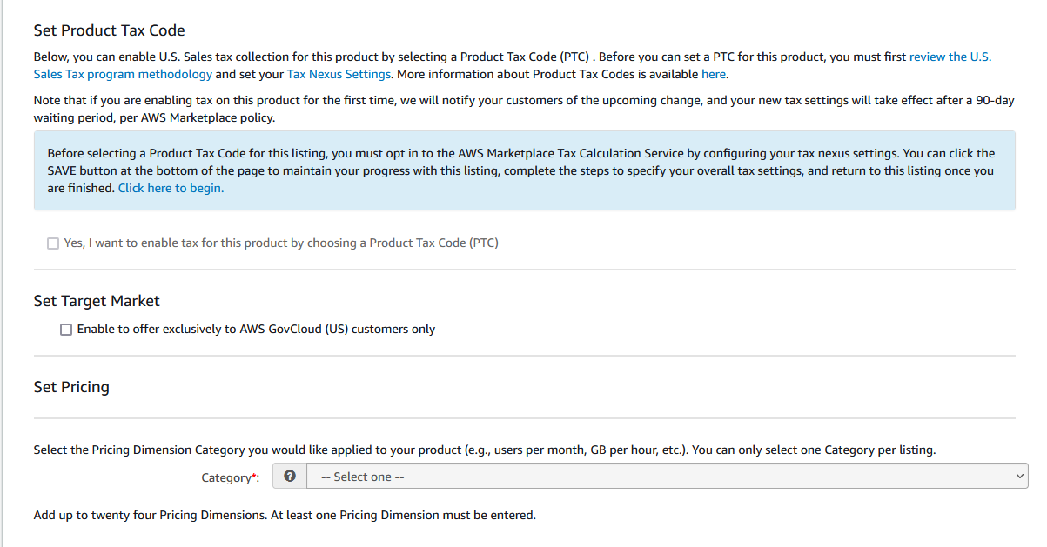

- Set Pricing;
Select the Pricing dimension, whether you want to set price based on hours, mbs and so on.
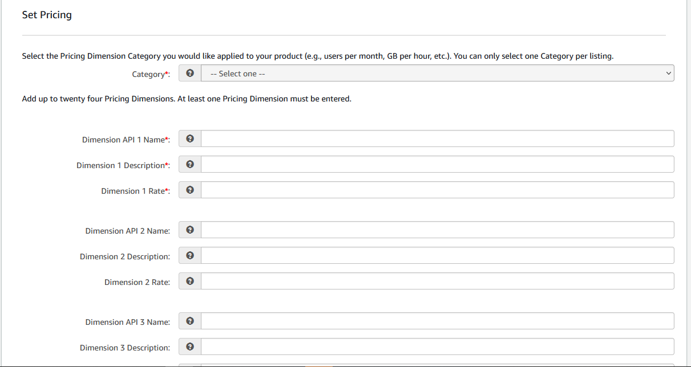
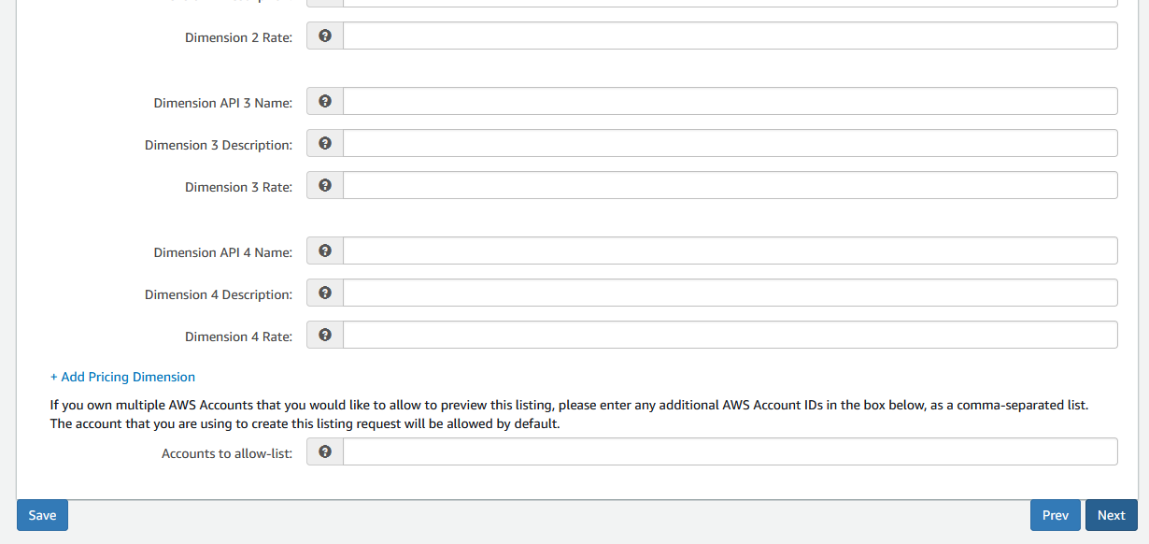
Here;
Dimension API Name – Specify the name of the Dimension API
Dimension Description - Describe the Dimension
Dimension Rate – Specify the price for that Dimension.

Note: Dimension basically means the Components or APIs in your SaaS product, for example if you have 4 components in your SaaS product and you want to set pricing for those separately so in that case you will specify Dimension API for each Component and set the pricing separately. (Think of SMC Components)

Accounts to allow-list - If you own multiple AWS Accounts that you would like to allow to preview this listing, please enter any additional AWS Account IDs in the box below, as a comma-separated list. The account that you are using to create this listing request will be allowed by default.
Now click on Next;

Step 8: Additional Notes
Enter additional publishing notes / instructions for the AWS Marketplace team here.
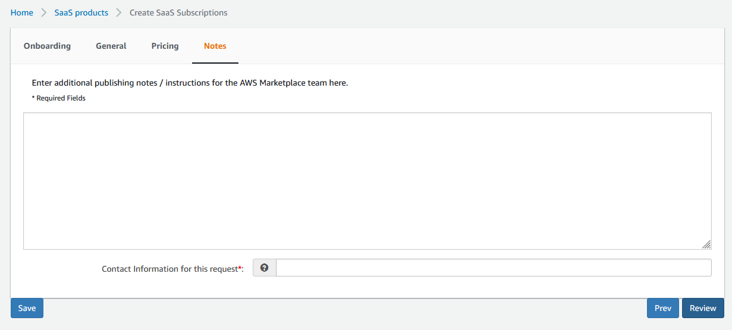
Fill the Contact details for this Product and click on Review;

Step 9: After you Click on the Review it will show all the details in the form that you have filled, once you re-check all the fields click on Submit for review.
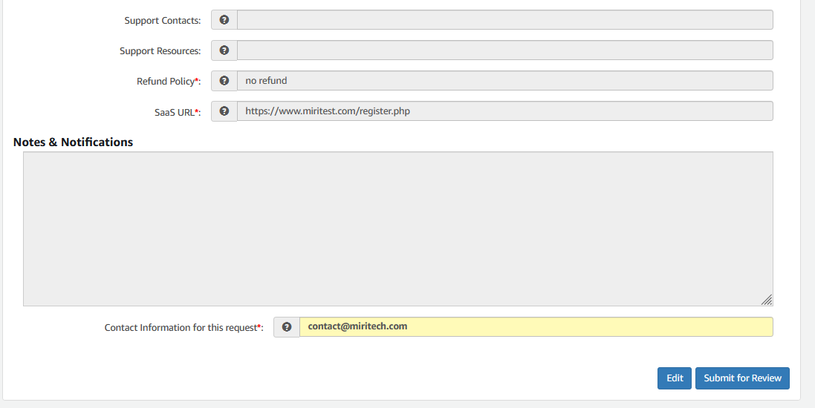
Now, the AWS marketplace Team will check the whole form and if all goes well your SaaS product will be published on the AWS Marketplace.

